UNITED STATES
SECURITIES AND EXCHANGE COMMISSION
WASHINGTON, D.C. 20549

FORM 8-K

CURRENT REPORT
Pursuant to Section 13 OR 15(d) of The Securities Exchange Act of 1934

Date of Report (Date of earliest event reported): August 06, 2026

KELLY SERVICES, INC.
---------------------------------------------------------------------
(Exact name of Registrant as specified in its charter)
Delaware |  |  | 0-1088 |  |  | 38-1510762
(State or other jurisdiction |  |  | (Commission |  |  | (IRS Employer
of incorporation) |  |  | File Number) |  |  | Identification No.)

999 West Big Beaver Road, Troy, Michigan 48084
-------------------------------------------------------------------------------
(Address of principal executive offices) (Zip Code)

(248) 362-4444
----------------------------------------------------------------------
(Registrant's telephone number, including area code)

Check the appropriate box below if the Form 8-K filing is intended to simultaneously satisfy the filing obligation of the registrant under any of the following provisions (see General Instruction A.2. below):

☐ Written communications pursuant to Rule 425 under the Securities Act (17 CFR 230.425)

☐ Soliciting material pursuant to Rule 14a-12 under the Exchange Act (17 CFR 240.14a-12)

☐ Pre-commencement communications pursuant to Rule 14d-2(b) under the Exchange Act (17 CFR 240.14d-2(b))

☐ Pre-commencement communications pursuant to Rule 13e-4(c) under the Exchange Act (17 CFR 240.13e-4(c))

Securities registered pursuant to Section 12(b) of the Act:
Title of each class |  |  | Trading Symbols |  |  | Name of each exchange on which registered
Class A Common Stock, $1.00 par value per share |  |  | KELYA |  |  | The Nasdaq Stock Market LLC
Class B Common Stock, $1.00 par value per share |  |  | KELYB |  |  | The Nasdaq Stock Market LLC

Indicate by check mark whether the registrant is an emerging growth company as defined in Rule 405 of the Securities Act of 1933 (§230.405 of this chapter) or Rule 12b-2 of the Securities Exchange Act of 1934 (§240.12b-2 of this chapter).

Emerging growth company ☐

If an emerging growth company, indicate by check mark if the registrant has elected not to use the extended transition period for complying with any new or revised financial accounting standards provided pursuant to Section 13(a) of the Exchange Act. ☐
1

Item 2.02. Results of Operations and Financial Condition

Kelly Services, Inc. (the “Company”) today released financial information containing highlighted financial data for the three and six months ended June 28, 2026. A copy of the press release is attached as Exhibit 99.1 to this Current Report on Form 8-K and incorporated herein by reference.

Item 9.01. Financial Statements and Exhibits

(d) Exhibits
Exhibit No. |  |  | Description
99.1 |  |  | Press Release dated August 6, 2026.
99.2 |  |  | Presentation materials for August 6, 2026 conference call.
104 |  |  | Cover Page Interactive Data File (embedded within the Inline XBRL document)

2

SIGNATURES

Pursuant to the requirements of the Securities Exchange Act of 1934, the registrant has duly caused this report to be signed on its behalf by the undersigned, hereunto duly authorized.

August 6, 2026
/s/ Nicholas A. Zuhlke
Nicholas A. Zuhlke
Vice President, Corporate Controller and
Chief Accounting Officer
(Principal Accounting Officer)

3

EXHIBIT INDEX

Exhibit No. |  |  | Description
99.1 |  |  | Press Release dated August 6, 2026.
99.2 |  |  | Presentation materials for August 6, 2026 conference call.
104 |  |  | Cover Page Interactive Data File (embedded within the Inline XBRL document)

4

Exhibit 99.1

Kelly Reports
Second-Quarter 2026 Earnings

TROY, Mich. (August 6, 2026) – Kelly (Nasdaq: KELYA, KELYB), a leading specialty talent solutions provider, today announced results for the second quarter of 2026.

•Q2 revenue of $1.0 billion, with year-over-year decline improving approximately 500 basis points (“bps”) versus the prior quarter; underlying revenue decline excluding previously disclosed discrete items improved 270 bps versus the prior quarter
•Underlying revenue year-over-year performance reflects strength in the ETM and SET segments with each improved at least 300 bps versus the prior quarter, along with a 40 bps improvement for the Education segment
•Q2 operating earnings of $16.1 million; $19.3 million of operating earnings on an adjusted basis
•Q2 adjusted EBITDA of $31.1 million and adjusted EBITDA margin of 3.0%, improved 110 bps on a year-over-year basis versus the prior quarter resulting from stable year-over-year gross profit rate and continued SG&A discipline
•Company increases its fiscal 2026 revenue outlook, now expecting a low-to-mid-single digit decline, and affirms its adjusted EBITDA margin expectation of modest year-over-year growth driven by accelerating underlying revenue growth and operating efficiencies

Chris Layden, chief executive officer, said, “In the second quarter, we measurably exceeded our guidance for both revenue and adjusted EBITDA margin driven by growing momentum from our growth and efficiency initiatives as well as constructive demand trends in parts of our portfolio. We delivered sequential improvements in each of our businesses as we continued to capitalize on organic growth drivers. Notably, Kelly’s adjusted EBITDA margin returned to 3.0% in the quarter, demonstrating our ability to generate operating leverage in pursuit of growth. Our progress strengthens our conviction in our strategy and reinforces our confidence in our expectation of further measurable improvement in our year-over-year performance as we progress through the second half of the year.”

Financial Results for the thirteen-week period ended June 28, 2026:

Revenue of $1.0 billion, a 5.8% decrease compared to the corresponding quarter of 2025. Discrete impacts associated with the previously disclosed reduced demand for U.S. federal government contractors in the SET segment and from three large commercial customers in the ETM segment totaled approximately 5.2%, resulting in an underlying revenue decline of approximately 0.6%. Underlying revenue performance includes overall growth from improved demand and new business in the ETM segment, including growth in staffing and each of the talent solutions specialties. Offsetting the growth was a measurably improved year-over-year decline within the SET segment which reflects continued year-over-year growth in the Telecom specialty and reduced declines in each of the SET specialties. SET revenue grew sequentially for the first time in over two years. Additionally, the Education segment showed an improved year-over-year decline which continues to be driven by delayed prior year contract decisions and declines in student enrollment in key markets.

Operating earnings of $16.1 million, compared to earnings of $22.2 million reported in the second quarter of 2025. Adjusted earnings1 were $19.3 million in the second quarter of 2026 and $24.6 million in the second quarter of 2025. Adjusted EBITDA1 of $31.1 million, a decrease of 15.9% versus the prior year period. Adjusted EBITDA margin of 3.0%, a decrease of 40 bps but improved 110 bps versus the prior quarter, reflects 10 bps lower gross margin partially offset by volume-related and structural expense management actions including benefits from our acquisition integration and technology modernization efforts. ETM showed year-over-year stability in its adjusted EBITDA margin while Education and SET both declined. Both ETM and SET improved their adjusted EBITDA margins measurably versus the prior quarter.

Income tax expense of $3.0 million, compared to income tax expense of $0.9 million reported in the second quarter of 2025. On an adjusted basis1, income tax expense of $3.8 million, compared to income tax expense of $2.5 million in the second quarter of 2025.

Earnings per share was $0.31 compared to earnings per share of $0.52 in the second quarter of 2025. On an adjusted basis1, earnings per share was $0.37 in the second quarter of 2026 compared to $0.54 per share in the corresponding quarter of 2025.

1
Financial Results for the 26-week period ended June 28, 2026:

Revenue of $2.1 billion, an 8.3% decrease compared to the corresponding period in 2025. Discrete impacts associated with the reduced demand for U.S. federal government contractors in the SET segment and from three large commercial customers in the ETM segment totaled approximately 6.3%, resulting in an underlying revenue decline of approximately 2.0%. Underlying revenue performance includes overall growth from improved demand in the ETM segment, including growth in each of the talent solutions specialties, along with growth in the Telecom specialty and improved performance in the Science and Engineering specialties within the SET segment. Offsetting this growth was continued lower demand in the other specialties within the SET segment, largely the Technology specialty, along with a decline in the Education segment driven by delayed prior year contract decisions and declines in student enrollment in key markets.

Operating earnings of $11.0 million, compared to earnings of $33.0 million reported over the same period in 2025. Adjusted earnings1 were $23.4 million in the first six months of 2026 and $46.7 million in the corresponding period of 2025. Adjusted EBITDA1 of $46.9 million, a decrease of 34.8% versus the prior year period. Adjusted EBITDA margin of 2.3%, a decrease of 90 bps, reflects near-term margin pressure in ETM, Education, and SET driven by lower gross margins and timing of revenue trends, partially offset by volume-related and structural expense management actions including benefits from our acquisition integration and technology modernization efforts.

Income tax expense of $2.2 million, compared to income tax expense of $2.7 million reported over the same period in 2025. On an adjusted basis1, income tax expense of $5.3 million, compared to income tax expense of $7.2 million in the corresponding period of 2025.

Earnings per share was $0.15, compared to earnings per share of $0.67 in the same period of 2025. On an adjusted basis1, earnings per share were $0.40 for the first six months of 2026 compared to $0.93 per share in the corresponding period of 2025.

1 Adjusted measures represent non-GAAP financial measures. Refer to our reconciliation of non-GAAP financial measures to the most closely related GAAP measure included in this document.

Financial Outlook For Fiscal 2026:

The Company's 2026 financial outlook has improved for revenue and remains unchanged for Adjusted EBITDA margin relative to the initial view previously disclosed, assumes no material change in the macroeconomic environment in the coming quarters, and is as follows:

•Third Quarter of 2026 – Expect year-over-year improvement relative to second quarter, with overall underlying revenue growth of 1% to 2%, and total revenue to be flat to a decline of 2% versus the prior year. Adjusted EBITDA margin in the low 2% range, representing 40 to 50 bps of year-over-year improvement relative to the prior year.
◦Outlook includes the seasonality impact of the Education business due to schools being out of session for the majority of the quarter which results in sequential revenue and profitability declines versus the second quarter.

•Fourth Quarter of 2026 – Expect substantial improvement in year-over-year performance versus third quarter for both revenue and adjusted EBITDA margin resulting in mid-to-upper single digits revenue growth and approximately 200 bps of year-over-year adjusted EBITDA margin expansion resulting in adjusted EBITDA margin of approximately 4%.
◦Outlook includes the impact of an extra fiscal week in the fourth quarter, which benefits revenue growth by approximately 4 points in the quarter, but negatively impacts adjusted EBITDA.

•Full Year 2026 – On a full year basis, expect low-to-mid single digit total revenue decline and a 10 to 20 bps year-over-year improvement in adjusted EBITDA margin.

Quarterly Cash Dividend:

Kelly also reported that on August 4, 2026, its board of directors declared a dividend of $0.075 per share. The dividend is payable on September 2, 2026 to stockholders of record as of the close of business on August 19, 2026.

In conjunction with its earnings release, Kelly has published a financial presentation and will host a live webcast of a conference call at 9 a.m. ET on August 6 to review the financial and operation results from the quarter. The presentation and a link to the live webcast will be accessible through the Company’s public website on the Investor Relations page under Events & Presentations. The webcast will be recorded, and a replay will be available within one hour of completion of the event through the same link as the live webcast.

2
Forward-Looking Statements:

This release contains statements that are forward looking in nature and, accordingly, are subject to risks and uncertainties. These statements are made under the “safe harbor” provisions of the U.S. Private Securities Litigation Reform Act of 1995. Statements that are not historical facts, including statements about Kelly’s financial expectations, are forward-looking statements. Factors that could cause actual results to differ materially from those contained in this release include, but are not limited to, (i) changing market and economic conditions, (ii) disruption in the labor market and weakened demand for human capital resulting from technological advances, competitive pressures and pricing, loss of large corporate customers and government contractor requirements, (iii) the impact of laws and regulations (including federal, state and international tax laws), (iv) unexpected changes in claim trends on workers’ compensation, unemployment, disability and medical benefit plans, (v) litigation and other legal liabilities (including tax liabilities) in excess of our estimates, (vi) our ability to achieve our business’s anticipated growth strategies, (vii) our future business development, results of operations and financial condition, (viii) damage to our brands, (ix) dependence on third parties for the execution of critical functions, (x) conducting business in foreign countries, including foreign currency fluctuations, (xi) availability of temporary workers with appropriate skills required by customers, (xii) cyberattacks or other breaches of network or information technology security, and (xiii) other risks, uncertainties and factors discussed in this release and in the Company’s filings with the Securities and Exchange Commission. In some cases, forward-looking statements can be identified by words or phrases such as “may,” “will,” “expect,” “anticipate,” “target,” “aim,” “estimate,” “intend,” “plan,” “believe,” “potential,” “continue,” “is/are likely to” or other similar expressions. All information provided in this press release is as of the date of this press release and we undertake no obligation to update any forward-looking statement, whether as a result of new information, future events, or otherwise, except as required by law.

About Kelly®

Kelly Services, Inc. (Nasdaq: KELYA, KELYB) helps companies recruit and manage skilled workers and helps job seekers find great work. Since inventing the staffing industry in 1946, we have become experts in the many industries and local and global markets we serve. With a network of suppliers and partners around the world, we connect approximately 375,000 people with work every year. Our suite of outsourcing and consulting services and solutions ensures companies have the people they need, when and where they are needed most. Headquartered in Troy, Michigan, we empower businesses and individuals to access limitless opportunities in industries such as science, engineering, technology, education, manufacturing, retail, finance, and energy. Revenue in 2025 was $4.3 billion. Learn more at kellyservices.com.

KLYA-FIN
# # #
ANALYST & MEDIA CONTACT:
Scott Thomas
(248) 251-7264
scott.thomas@kellyservices.com

3
KELLY SERVICES, INC.
CONSOLIDATED STATEMENTS OF EARNINGS
FOR THE 13 WEEKS ENDED JUNE 28, 2026 AND JUNE 29, 2025
(UNAUDITED)
(in millions, except per share data)
 |  |  | 2026 |  |  | 2025 |  |  |  |  | Change |  |  | % Change(1)
Revenue from services |  |  | $ | 1,038.2 |  | $ | 1,101.8 |  |  |  | $ | (63.6) |  | (5.8) |  | %
Cost of services |  |  | 826.2 |  |  | 876.3 |  |  |  |  | (50.1) |  |  | (5.7)
Gross profit |  |  | 212.0 |  |  | 225.5 |  |  |  |  | (13.5) |  |  | (6.0)
Selling, general and administrative expenses |  |  | 195.9 |  |  | 207.3 |  |  |  |  | (11.4) |  |  | (5.5)
Gain on sale of EMEA staffing operations |  |  | — |  |  | (4.0) |  |  |  |  | 4.0 |  |  | NM
Earnings from operations |  |  | 16.1 |  |  | 22.2 |  |  |  |  | (6.1) |  |  | (27.5)
Other income (expense), net |  |  | (1.7) |  |  | (2.3) |  |  |  |  | 0.6 |  |  | 26.1
Earnings before taxes |  |  | 14.4 |  |  | 19.9 |  |  |  |  | (5.5) |  |  | (27.6)
Income tax expense |  |  | 3.0 |  |  | 0.9 |  |  |  |  | 2.1 |  |  | 233.3
Net earnings |  |  | $ | 11.4 |  | $ | 19.0 |  |  |  | $ | (7.6) |  | (40.0) |  | %
Basic earnings per share |  |  | $ | 0.31 |  | $ | 0.52 |  |  |  | $ | (0.21) |  | (40.4) |  | %
Diluted earnings per share |  |  | $ | 0.31 |  | $ | 0.52 |  |  |  | $ | (0.21) |  | (40.4) |  | %
STATISTICS:
Permanent placement income (included in revenue from services) |  |  | $ | 13.7 |  | $ | 14.8 |  |  |  | $ | (1.1) |  | (7.4) |  | %
Gross profit rate |  |  | 20.4 |  | % | 20.5 |  | % |  |  | (0.1) |  | pts.
Adjusted EBITDA |  |  | $ | 31.1 |  | $ | 37.0 |  |  |  | $ | (5.9) |  | (15.9) |  | %
Adjusted EBITDA margin |  |  | 3.0 |  | % | 3.4 |  | % |  |  | (0.4) |  | pts.
Effective income tax rate |  |  | 21.2 |  | % | 4.2 |  | % |  |  | 17.0 |  | pts.
Average shares outstanding:
Basic |  |  | 34.7 |  |  | 35.2
Diluted |  |  | 35.2 |  |  | 35.7

(1) Reported percentage changes are computed based on millions. Prior year percent changes were computed based on actual amounts in thousands.

4

KELLY SERVICES, INC.
CONSOLIDATED STATEMENTS OF EARNINGS
FOR THE 26 WEEKS ENDED JUNE 28, 2026 AND JUNE 29, 2025
(UNAUDITED)
(in millions, except per share data)
 |  |  |  |  | 2026 |  |  | 2025 |  |  |  |  | Change |  |  | % Change(1)
Revenue from services |  |  |  |  | $ | 2,078.9 |  | $ | 2,266.7 |  |  |  | $ | (187.8) |  | (8.3) |  | %
Cost of services |  |  |  |  | 1,670.5 |  |  | 1,804.7 |  |  |  |  | (134.2) |  |  | (7.4)
Gross profit |  |  |  |  | 408.4 |  |  | 462.0 |  |  |  |  | (53.6) |  |  | (11.6)
Selling, general and administrative expenses |  |  |  |  | 395.2 |  |  | 433.0 |  |  |  |  | (37.8) |  |  | (8.7)
Asset impairment charge |  |  |  |  | 2.2 |  |  | — |  |  |  |  | 2.2 |  |  | NM
Gain on sale of EMEA staffing operations |  |  |  |  | — |  |  | (4.0) |  |  |  |  | 4.0 |  |  | NM
Earnings from operations |  |  |  |  | 11.0 |  |  | 33.0 |  |  |  |  | (22.0) |  |  | (66.7)
Other income (expense), net |  |  |  |  | (3.3) |  |  | (5.5) |  |  |  |  | 2.2 |  |  | 40.0
Earnings before taxes |  |  |  |  | 7.7 |  |  | 27.5 |  |  |  |  | (19.8) |  |  | (72.0)
Income tax expense |  |  |  |  | 2.2 |  |  | 2.7 |  |  |  |  | (0.5) |  |  | (18.5)
Net earnings |  |  |  |  | $ | 5.5 |  | $ | 24.8 |  |  |  | $ | (19.3) |  | (77.8) |  | %
Basic earnings per share |  |  |  |  | $ | 0.15 |  | $ | 0.68 |  |  |  | $ | (0.53) |  | (77.9) |  | %
Diluted earnings per share |  |  |  |  | $ | 0.15 |  | $ | 0.67 |  |  |  | $ | (0.52) |  | (77.6) |  | %
STATISTICS:
Permanent placement income (included in revenue from services) |  |  |  |  | $ | 24.6 |  | $ | 26.3 |  |  |  | $ | (1.7) |  | (6.5) |  | %
Gross profit rate |  |  |  |  | 19.6 |  | % | 20.4 |  | % |  |  | (0.8) |  | pts.
Adjusted EBITDA |  |  |  |  | $ | 46.9 |  | $ | 71.9 |  |  |  | $ | (25.0) |  | (34.8) |  | %
Adjusted EBITDA margin |  |  |  |  | 2.3 |  | % | 3.2 |  | % |  |  | (0.9) |  | pts.
Effective income tax rate |  |  |  |  | 29.4 |  | % | 9.7 |  | % |  |  | 19.7 |  | pts.
Average shares outstanding:
Basic |  |  |  |  | 34.6 |  |  | 35.1
Diluted |  |  |  |  | 35.1 |  |  | 35.6

(1) Reported percentage changes are computed based on millions. Prior year percent changes were computed based on actual amounts in thousands.

5
KELLY SERVICES, INC.
CONSOLIDATED BALANCE SHEETS
(UNAUDITED)
(in millions)
 |  |  | June 28, 2026 |  |  | December 28, 2025 |  |  | June 29, 2025
Current Assets
Cash and equivalents |  |  | $ | 24.2 |  | $ | 33.0 |  | $ | 18.0
Trade accounts receivable, less allowances of $9.7, $10.0 and $10.8, respectively |  |  | 1,224.6 |  |  | 1,188.7 |  |  | 1,181.1
Prepaid expenses and other current assets |  |  | 47.7 |  |  | 46.6 |  |  | 54.0
Total current assets |  |  | 1,296.5 |  |  | 1,268.3 |  |  | 1,253.1
Noncurrent Assets
Property and equipment, net |  |  | 18.0 |  |  | 20.5 |  |  | 22.8
Operating lease right-of-use assets |  |  | 35.5 |  |  | 42.9 |  |  | 44.5
Deferred taxes |  |  | 164.2 |  |  | 163.2 |  |  | 337.3
Retirement plan assets |  |  | 309.9 |  |  | 289.7 |  |  | 272.1
Goodwill |  |  | 202.1 |  |  | 202.1 |  |  | 304.1
Intangibles, net |  |  | 211.5 |  |  | 226.2 |  |  | 241.0
Other assets |  |  | 43.0 |  |  | 37.7 |  |  | 37.0
Total noncurrent assets |  |  | 984.2 |  |  | 982.3 |  |  | 1,258.8
Total Assets |  |  | $ | 2,280.7 |  | $ | 2,250.6 |  | $ | 2,511.9
Current Liabilities
Accounts payable and accrued liabilities |  |  | $ | 661.6 |  | $ | 631.4 |  | $ | 613.8
Operating lease liabilities |  |  | 10.8 |  |  | 12.3 |  |  | 12.1
Accrued payroll and related taxes |  |  | 155.5 |  |  | 140.9 |  |  | 161.6
Accrued workers' compensation and other claims |  |  | 21.0 |  |  | 20.9 |  |  | 18.8
Income and other taxes |  |  | 17.7 |  |  | 16.3 |  |  | 20.4
Total current liabilities |  |  | 866.6 |  |  | 821.8 |  |  | 826.7
Noncurrent Liabilities
Long-term debt |  |  | 78.1 |  |  | 101.9 |  |  | 74.3
Operating lease liabilities |  |  | 39.8 |  |  | 44.9 |  |  | 47.5
Accrued workers' compensation and other claims |  |  | 34.3 |  |  | 34.2 |  |  | 33.4
Accrued retirement benefits |  |  | 272.7 |  |  | 263.7 |  |  | 254.5
Other long-term liabilities |  |  | 7.2 |  |  | 7.6 |  |  | 9.4
Total noncurrent liabilities |  |  | 432.1 |  |  | 452.3 |  |  | 419.1
Commitments and contingencies (see Contingencies footnote)
Stockholders' Equity
Common Stock |  |  | 38.5 |  |  | 38.5 |  |  | 38.5
Treasury Stock |  |  | (55.8) |  |  | (63.7) |  |  | (55.3)
Paid-in capital |  |  | 35.1 |  |  | 36.3 |  |  | 34.0
Earnings invested in the business |  |  | 965.1 |  |  | 965.1 |  |  | 1,249.5
Accumulated other comprehensive income (loss) |  |  | (0.9) |  |  | 0.3 |  |  | (0.6)
Total stockholders' equity |  |  | 982.0 |  |  | 976.5 |  |  | 1,266.1
Total Liabilities and Stockholders' Equity |  |  | $ | 2,280.7 |  | $ | 2,250.6 |  | $ | 2,511.9
STATISTICS:
Working Capital |  |  | $ | 429.9 |  | $ | 446.5 |  | $ | 426.4
Current Ratio |  |  | 1.5 |  |  | 1.5 |  |  | 1.5
Debt-to-capital % |  |  | 7.4 |  | % | 9.4 |  | % | 5.5 |  | %
Global Days Sales Outstanding |  |  | 61 |  |  | 61 |  |  | 59
Year-to-Date Free Cash Flow |  |  | $ | 21.2 |  | $ | 114.1 |  | $ | 114.8

6
KELLY SERVICES, INC.
CONSOLIDATED STATEMENTS OF CASH FLOWS
FOR THE 26 WEEKS ENDED JUNE 28, 2026 AND JUNE 29, 2025
(UNAUDITED)
(in millions)
 |  |  | 2026 |  |  | 2025
Cash flows from operating activities:
Net earnings |  |  | $ | 5.5 |  | $ | 24.8
Adjustments to reconcile net earnings to net cash from operating activities:
Asset impairment charge |  |  | 2.2 |  |  | —
Deferred income taxes |  |  | (1.0) |  |  | (6.9)
Gain on sale of EMEA staffing operations |  |  | — |  |  | (4.0)
Depreciation and amortization |  |  | 19.7 |  |  | 21.5
Operating lease asset amortization |  |  | 5.2 |  |  | 5.4
Provision for credit losses and sales allowances |  |  | 0.8 |  |  | 3.2
Stock-based compensation |  |  | 6.8 |  |  | 7.2
Other, net |  |  | 1.0 |  |  | (0.1)
Changes in operating assets and liabilities
Accounts receivable |  |  | (43.6) |  |  | 91.9
Other assets |  |  | (2.8) |  |  | 3.2
Accounts payable |  |  | 36.7 |  |  | (19.8)
Other liabilities |  |  | (6.7) |  |  | (7.1)
Net cash from operating activities |  |  | 23.8 |  |  | 119.3
Cash flows from investing activities:
Capital expenditures |  |  | (2.6) |  |  | (4.5)
Proceeds from sale of EMEA staffing operations, net of cash disposed |  |  | — |  |  | 21.8
Proceeds from company-owned life insurance |  |  | 2.7 |  |  | 1.6
Proceeds from sale of PersolKelly investment |  |  | — |  |  | 6.4
Other investing activities |  |  | 0.1 |  |  | (0.6)
Net cash from investing activities |  |  | 0.2 |  |  | 24.7
Cash flows from financing activities:
Proceeds from long-term debt |  |  | 718.8 |  |  | 774.4
Payments on long-term debt |  |  | (742.6) |  |  | (939.5)
Dividend payments |  |  | (5.5) |  |  | (5.5)
Payments of tax withholding for stock awards |  |  | (1.5) |  |  | (1.9)
Other financing activities |  |  | (0.4) |  |  | (0.2)
Net cash used in financing activities |  |  | (31.2) |  |  | (172.7)
Effect of exchange rates on cash, cash equivalents and restricted cash |  |  | (2.5) |  |  | 7.6
Net change in cash, cash equivalents and restricted cash |  |  | (9.7) |  |  | (21.1)
Cash, cash equivalents and restricted cash at beginning of period |  |  | 37.7 |  |  | 45.6
Cash, cash equivalents and restricted cash at end of period |  |  | $ | 28.0 |  | $ | 24.5

7
KELLY SERVICES, INC.
SEGMENT INFORMATION
(UNAUDITED)
(in millions)
We utilize business unit profit (loss) to evaluate the performance of our segments. Business unit profit (loss) and SG&A expenses as presented in the segment information table below do not include depreciation and amortization expenses.
 |  |  | Second Quarter
 |  |  | 2026 |  |  | 2025 |  |  | % Change
Enterprise Talent Management
Revenue from services |  |  | $ | 485.5 |  | $ | 516.4 |  | (6.0) |  | %
Gross profit |  |  | 99.5 |  |  | 103.4 |  |  | (3.8)
Adjusted SG&A expenses |  |  | 88.7 |  |  | 91.7 |  |  | (3.3)
Integration, realignment and restructuring charges(2) |  |  | — |  |  | 1.1 |  |  | NM
Total SG&A expenses |  |  | 88.7 |  |  | 92.8 |  |  | (4.4)
Business unit profit |  |  | 10.8 |  |  | 10.6 |  |  | 1.9
Adjusted business unit profit |  |  | 10.8 |  |  | 11.7 |  |  | (7.7)
Gross profit rate |  |  | 20.5 |  | % | 20.0 |  | % | 0.5 |  | pts.
Science, Engineering & Technology
Revenue from services |  |  | $ | 301.6 |  | $ | 321.1 |  | (6.1) |  | %
Gross profit |  |  | 76.5 |  |  | 83.0 |  |  | (7.8)
Adjusted SG&A expenses |  |  | 58.1 |  |  | 62.3 |  |  | (6.7)
Integration, realignment and restructuring charges(2) |  |  | 0.2 |  |  | 0.9 |  |  | (77.8)
Total SG&A expenses |  |  | 58.3 |  |  | 63.2 |  |  | (7.8)
Business unit profit |  |  | 18.2 |  |  | 19.8 |  |  | (8.1)
Adjusted business unit profit |  |  | 18.4 |  |  | 20.7 |  |  | (11.1)
Gross profit rate |  |  | 25.4 |  | % | 25.8 |  | % | (0.4) |  | pts.
Education
Revenue from services |  |  | $ | 253.5 |  | $ | 265.3 |  | (4.4) |  | %
Gross profit |  |  | 36.0 |  |  | 39.1 |  |  | (7.9)
Adjusted SG&A expenses |  |  | 25.3 |  |  | 25.4 |  |  | (0.4)
Integration, realignment and restructuring charges(2) |  |  | — |  |  | 0.1 |  |  | NM
Total SG&A expenses |  |  | 25.3 |  |  | 25.5 |  |  | (0.8)
Business unit profit |  |  | 10.7 |  |  | 13.6 |  |  | (21.3)
Adjusted business unit profit |  |  | 10.7 |  |  | 13.7 |  |  | (21.9)
Gross profit rate |  |  | 14.2 |  | % | 14.7 |  | % | (0.5) |  | pts.

8
KELLY SERVICES, INC.
RESULTS OF OPERATIONS BY SEGMENT
(UNAUDITED)
(in millions)
We utilize business unit profit (loss) to evaluate the performance of our segments. Business unit profit (loss) and SG&A expenses as presented in the segment information table below do not include depreciation and amortization expenses.
 |  |  | June Year-to-Date
 |  |  | 2026 |  |  | 2025 |  |  | % Change
Enterprise Talent Management
Revenue from services |  |  | $ | 944.7 |  | $ | 1,045.5 |  | (9.6) |  | %
Gross profit |  |  | 185.1 |  |  | 210.7 |  |  | (12.1)
Adjusted SG&A expenses |  |  | 175.6 |  |  | 190.0 |  |  | (7.6)
Integration, realignment and restructuring charges(2) |  |  | — |  |  | 3.8 |  |  | NM
Total SG&A expenses |  |  | 175.6 |  |  | 193.8 |  |  | (9.4)
Business unit profit |  |  | 9.5 |  |  | 16.9 |  |  | (43.8)
Adjusted business unit profit |  |  | 9.5 |  |  | 20.7 |  |  | (54.1)
Gross profit rate |  |  | 19.6 |  | % | 20.1 |  | % | (0.5) |  | pts.
Science, Engineering & Technology
Revenue from services |  |  | $ | 590.8 |  | $ | 648.4 |  | (8.9) |  | %
Gross profit |  |  | 148.3 |  |  | 166.0 |  |  | (10.7)
Adjusted SG&A expenses |  |  | 115.4 |  |  | 130.3 |  |  | (11.4)
Integration, realignment and restructuring charges(2) |  |  | 0.5 |  |  | 2.0 |  |  | (75.0)
Total SG&A expenses |  |  | 115.9 |  |  | 132.3 |  |  | (12.4)
Asset impairment charge(5) |  |  | 2.2 |  |  | — |  |  | NM
Business unit profit |  |  | 30.2 |  |  | 33.7 |  |  | (10.4)
Adjusted business unit profit |  |  | 32.9 |  |  | 35.7 |  |  | (7.8)
Gross profit rate |  |  | 25.1 |  | % | 25.6 |  | % | (0.5) |  | pts.
Education
Revenue from services |  |  | $ | 547.6 |  | $ | 574.3 |  | (4.6) |  | %
Gross profit |  |  | 75.0 |  |  | 85.3 |  |  | (12.1)
Adjusted SG&A expenses |  |  | 51.9 |  |  | 52.3 |  |  | (0.8)
Integration, realignment and restructuring charges(2) |  |  | 0.1 |  |  | 0.1 |  |  | —
Total SG&A expenses |  |  | 52.0 |  |  | 52.4 |  |  | (0.8)
Business unit profit |  |  | 23.0 |  |  | 32.9 |  |  | (30.1)
Adjusted business unit profit |  |  | 23.1 |  |  | 33.0 |  |  | (30.0)
Gross profit rate |  |  | 13.7 |  | % | 14.9 |  | % | (1.2) |  | pts.

9
KELLY SERVICES, INC.
REVENUE FROM SERVICES BY SERVICE TYPE
(UNAUDITED)
(in millions)
 |  |  | Second Quarter 2026
 |  |  | Staffing Services |  |  | Outcome-based Services |  |  | Talent Solutions |  |  | Permanent Placement |  |  | Total
Enterprise Talent Management |  |  | $ | 239.3 |  | $ | 109.6 |  | $ | 134.9 |  | $ | 1.7 |  | $ | 485.5
Science, Engineering & Technology |  |  | 172.9 |  |  | 118.7 |  |  | — |  |  | 10.0 |  |  | 301.6
Education |  |  | 251.5 |  |  | — |  |  | — |  |  | 2.0 |  |  | 253.5
Total Segment Revenue |  |  | $ | 663.7 |  | $ | 228.3 |  | $ | 134.9 |  | $ | 13.7 |  | $ | 1,040.6
Intersegment |  |  |  |  |  |  |  |  |  |  |  |  |  |  | (2.4)
Total Revenue from Services |  |  |  |  |  |  |  |  |  |  |  |  |  |  | $ | 1,038.2
 |  |  | Second Quarter 2025
 |  |  | Staffing Services |  |  | Outcome-based Services |  |  | Talent Solutions |  |  | Permanent Placement |  |  | Total
Enterprise Talent Management |  |  | $ | 265.8 |  | $ | 120.8 |  | $ | 126.9 |  | $ | 2.9 |  | $ | 516.4
Science, Engineering & Technology |  |  | 204.5 |  |  | 107.3 |  |  | — |  |  | 9.3 |  |  | 321.1
Education |  |  | 262.7 |  |  | — |  |  | — |  |  | 2.6 |  |  | 265.3
Total Segment Revenue |  |  | $ | 733.0 |  | $ | 228.1 |  | $ | 126.9 |  | $ | 14.8 |  | $ | 1,102.8
Intersegment |  |  |  |  |  |  |  |  |  |  |  |  |  |  | (1.0)
Total Revenue from Services |  |  |  |  |  |  |  |  |  |  |  |  |  |  | $ | 1,101.8

10
KELLY SERVICES, INC.
REVENUE FROM SERVICES BY SERVICE TYPE (continued)
(UNAUDITED)
(in millions)
 |  |  | June Year-to-Date 2026
 |  |  | Staffing Services |  |  | Outcome-based Services |  |  | Talent Solutions |  |  | Permanent Placement |  |  | Total
Enterprise Talent Management |  |  | $ | 468.6 |  | $ | 216.4 |  | $ | 256.2 |  | $ | 3.5 |  | $ | 944.7
Science, Engineering & Technology |  |  | 341.5 |  |  | 230.9 |  |  | — |  |  | 18.4 |  |  | 590.8
Education |  |  | 544.9 |  |  | — |  |  | — |  |  | 2.7 |  |  | 547.6
Total Segment Revenue |  |  | $ | 1,355.0 |  | $ | 447.3 |  | $ | 256.2 |  | $ | 24.6 |  | $ | 2,083.1
Intersegment |  |  |  |  |  |  |  |  |  |  |  |  |  |  | (4.2)
Total Revenue from Services |  |  |  |  |  |  |  |  |  |  |  |  |  |  | $ | 2,078.9
 |  |  | June Year-to-Date 2025
 |  |  | Staffing Services |  |  | Outcome-based Services |  |  | Talent Solutions |  |  | Permanent Placement |  |  | Total
Enterprise Talent Management |  |  | $ | 541.6 |  | $ | 254.0 |  | $ | 244.7 |  | $ | 5.2 |  | $ | 1,045.5
Science, Engineering & Technology |  |  | 414.3 |  |  | 216.7 |  |  | — |  |  | 17.4 |  |  | 648.4
Education |  |  | 570.6 |  |  | — |  |  | — |  |  | 3.7 |  |  | 574.3
Total Segment Revenue |  |  | $ | 1,526.5 |  | $ | 470.7 |  | $ | 244.7 |  | $ | 26.3 |  | $ | 2,268.2
Intersegment |  |  |  |  |  |  |  |  |  |  |  |  |  |  | (1.5)
Total Revenue from Services |  |  |  |  |  |  |  |  |  |  |  |  |  |  | $ | 2,266.7

11
KELLY SERVICES, INC.
RECONCILIATION OF NON-GAAP MEASURES
(UNAUDITED)
(in millions, except per share data)

 |  |  | Second Quarter |  |  |  |  |  | June Year-to-Date
Adjusted SG&A expenses: |  |  | 2026 |  |  | 2025 |  |  | 2026 |  |  | 2025
As reported |  |  | $ | 195.9 |  | $ | 207.3 |  | $ | 395.2 |  | $ | 433.0
Integration, realignment and restructuring charges(2) |  |  | (2.9) |  |  | (6.1) |  |  | (7.6) |  |  | (16.8)
Transaction costs(3) |  |  | — |  |  | (0.1) |  |  | (0.8) |  |  | (0.4)
Executive transition costs(4) |  |  | (0.3) |  |  | (0.2) |  |  | (1.8) |  |  | (0.5)
Adjusted SG&A expenses |  |  | $ | 192.7 |  | $ | 200.9 |  | $ | 385.0 |  | $ | 415.3

 |  |  | Second Quarter |  |  |  |  |  | June Year-to-Date
Adjusted earnings from operations: |  |  | 2026 |  |  | 2025 |  |  | 2026 |  |  | 2025
As reported |  |  | $ | 16.1 |  | $ | 22.2 |  | $ | 11.0 |  | $ | 33.0
Integration, realignment and restructuring charges(2) |  |  | 2.9 |  |  | 6.1 |  |  | 7.6 |  |  | 16.8
Transaction costs(3) |  |  | — |  |  | 0.1 |  |  | 0.8 |  |  | 0.4
Executive transition costs(4) |  |  | 0.3 |  |  | 0.2 |  |  | 1.8 |  |  | 0.5
Asset impairment charge(5) |  |  | — |  |  | — |  |  | 2.2 |  |  | —
Gain on sale of EMEA staffing operations(6) |  |  | — |  |  | (4.0) |  |  | — |  |  | (4.0)
Adjusted earnings from operations |  |  | $ | 19.3 |  | $ | 24.6 |  | $ | 23.4 |  | $ | 46.7

 |  |  | Second Quarter |  |  |  |  |  | June Year-to-Date
Adjusted income tax expense: |  |  | 2026 |  |  | 2025 |  |  | 2026 |  |  | 2025
Income tax expense |  |  | $ | 3.0 |  | $ | 0.9 |  | $ | 2.2 |  | $ | 2.7
Taxes on integration, realignment and restructuring charges(2) |  |  | 0.7 |  |  | 1.6 |  |  | 1.9 |  |  | 4.3
Taxes on transaction costs(3) |  |  | — |  |  | — |  |  | 0.2 |  |  | 0.1
Taxes on executive transition costs(4) |  |  | 0.1 |  |  | — |  |  | 0.5 |  |  | 0.1
Taxes on asset impairment charge(5) |  |  | — |  |  | — |  |  | 0.5 |  |  | —
Adjusted income tax expense |  |  | $ | 3.8 |  | $ | 2.5 |  | $ | 5.3 |  | $ | 7.2

 |  |  | Second Quarter |  |  |  |  |  | June Year-to-Date
Adjusted net earnings and earnings per share: |  |  | 2026 |  |  | 2025 |  |  | 2026 |  |  | 2025
Net earnings |  |  | $ | 11.4 |  | $ | 19.0 |  | $ | 5.5 |  | $ | 24.8
Integration, realignment and restructuring charges, net of taxes(2) |  |  | 2.2 |  |  | 4.5 |  |  | 5.7 |  |  | 12.5
Transaction costs, net of taxes(3) |  |  | — |  |  | 0.1 |  |  | 0.6 |  |  | 0.4
Executive transition costs, net of taxes(4) |  |  | 0.2 |  |  | 0.2 |  |  | 1.3 |  |  | 0.4
Asset impairment charge, net of taxes(5) |  |  | — |  |  | — |  |  | 1.7 |  |  | —
Gain on sale of EMEA staffing operations, net of taxes(6) |  |  | — |  |  | (4.0) |  |  | — |  |  | (4.0)
Adjusted net earnings |  |  | $ | 13.8 |  | $ | 19.8 |  | $ | 14.8 |  | $ | 34.1
Diluted earnings per share |  |  | $ | 0.31 |  | $ | 0.52 |  | $ | 0.15 |  | $ | 0.67
Adjusted diluted earnings per share |  |  | $ | 0.37 |  | $ | 0.54 |  | $ | 0.40 |  | $ | 0.93

Note: Earnings per share amounts for each quarter are required to be computed independently and may not equal the amounts computed for the total year. Adjusted diluted earnings per share reflects the impact of potentially dilutive securities.

12
KELLY SERVICES, INC.
RECONCILIATION OF NON-GAAP MEASURES
(UNAUDITED)
(in millions)

 |  |  | Second Quarter |  |  |  |  |  | June Year-to-Date
Total Adjusted EBITDA: |  |  | 2026 |  |  | 2025 |  |  | 2026 |  |  | 2025
Net earnings |  |  | $ | 11.4 |  | $ | 19.0 |  | $ | 5.5 |  | $ | 24.8
Other (income) expense, net |  |  | 1.7 |  |  | 2.3 |  |  | 3.3 |  |  | 5.4
Income tax expense (benefit) |  |  | 3.0 |  |  | 0.9 |  |  | 2.2 |  |  | 2.7
Depreciation and amortization(7) |  |  | 11.8 |  |  | 12.5 |  |  | 23.5 |  |  | 25.3
EBITDA |  |  | 27.9 |  |  | 34.7 |  |  | 34.5 |  |  | 58.2
Integration, realignment and restructuring charges(2) |  |  | 2.9 |  |  | 6.0 |  |  | 7.6 |  |  | 16.7
Transaction costs(3) |  |  | — |  |  | 0.1 |  |  | 0.8 |  |  | 0.5
Executive transition costs(4) |  |  | 0.3 |  |  | 0.2 |  |  | 1.8 |  |  | 0.5
Asset impairment charge(5) |  |  | — |  |  | — |  |  | 2.2 |  |  | —
Gain on sale of EMEA staffing operations(6) |  |  | — |  |  | (4.0) |  |  | — |  |  | (4.0)
Adjusted EBITDA |  |  | $ | 31.1 |  | $ | 37.0 |  | $ | 46.9 |  | $ | 71.9
Adjusted EBITDA margin |  |  | 3.0 |  | % | 3.4 |  | % | 2.3 |  | % | 3.2 |  | %

 |  |  | Second Quarter 2026
Business Unit Adjusted EBITDA: |  |  | Enterprise Talent Management |  |  | Science, Engineering & Technology |  |  | Education
Business unit profit |  |  | $ | 10.8 |  | $ | 18.2 |  | $ | 10.7
Integration, realignment and restructuring charges(2) |  |  | — |  |  | 0.2 |  |  | —
Adjusted EBITDA |  |  | $ | 10.8 |  | $ | 18.4 |  | $ | 10.7
Adjusted EBITDA margin |  |  | 2.2 |  | % | 6.1 |  | % | 4.2 |  | %
 |  |  | Second Quarter 2025
 |  |  | Enterprise Talent Management |  |  | Science, Engineering & Technology |  |  | Education
Business unit profit |  |  | $ | 10.6 |  | $ | 19.8 |  | $ | 13.6
Integration, realignment and restructuring charges(2) |  |  | 1.1 |  |  | 0.9 |  |  | 0.1
Adjusted EBITDA |  |  | $ | 11.7 |  | $ | 20.7 |  | $ | 13.7
Adjusted EBITDA margin |  |  | 2.3 |  | % | 6.4 |  | % | 5.2 |  | %

13
KELLY SERVICES, INC. AND SUBSIDIARIES
RECONCILIATION OF NON-GAAP MEASURES
(UNAUDITED)
(In millions of dollars)
Business Unit Adjusted EBITDA (continued):
 |  |  | June Year-to-Date 2026
 |  |  | Enterprise Talent Management |  |  | Science, Engineering & Technology |  |  | Education
Business unit profit |  |  | $ | 9.5 |  | $ | 30.2 |  | $ | 23.0
Integration and realignment costs(2) |  |  | — |  |  | 0.5 |  |  | 0.1
Asset impairment charge(5) |  |  | — |  |  | 2.2 |  |  | —
Adjusted EBITDA |  |  | $ | 9.5 |  | $ | 32.9 |  | $ | 23.1
Adjusted EBITDA margin |  |  | 1.0 |  | % | 5.6 |  | % | 4.2 |  | %
 |  |  | June Year-to-Date 2025
 |  |  | Enterprise Talent Management |  |  | Science, Engineering & Technology |  |  | Education
Business unit profit (loss) |  |  | $ | 16.9 |  | $ | 33.7 |  | $ | 32.9
Integration and realignment costs(2) |  |  | 3.8 |  |  | 2.0 |  |  | 0.1
Adjusted EBITDA |  |  | $ | 20.7 |  | $ | 35.7 |  | $ | 33.0
Adjusted EBITDA margin |  |  | 2.0 |  | % | 5.5 |  | % | 5.7 |  | %

 |  |  |  | June Year-to-Date
Free cash flows: |  |  |  |  | 2026 |  |  | 2025
Net cash from operating activities |  |  |  |  | $ | 23.8 |  | $ | 119.3
Capital expenditures |  |  |  |  | (2.6) |  |  | (4.5)
Free Cash Flow |  |  |  |  | $ | 21.2 |  | $ | 114.8

14
KELLY SERVICES, INC.
RECONCILIATION OF NON-GAAP MEASURES
(UNAUDITED)

Management uses adjusted EBITDA (adjusted earnings before interest, taxes, depreciation and amortization) and adjusted EBITDA Margin (percent of total GAAP revenue) which Management believes is useful to compare operating performance compared to prior periods and uses it in conjunction with GAAP measures to assess performance. Our calculation of adjusted EBITDA may not be consistent with similarly titled measures of other companies and should be used in conjunction with GAAP measurements. Management also uses year-to-date free cash flow (operating cash flows less capital expenditures) to indicate the change in cash balances arising from operating activities, net of working capital needs and expenditures on fixed assets.

Management believes that the non-GAAP (U.S. Generally Accepted Accounting Principles) information excluding items such as integration, realignment and restructuring charges, transaction costs, executive transition costs, asset impairment charges and gain on the sale of our EMEA staffing operations are useful to understand the Company's fiscal 2026 financial performance and increases comparability. Specifically, Management believes that removing the impact of these items allows for a meaningful comparison of current period operating performance with the operating results of prior periods. Management also believes that such measures are used by those analyzing performance of companies in the staffing industry to compare current performance to prior periods and to assess future performance.

These non-GAAP measures may have limitations as analytical tools because they exclude items which can have a material impact on cash flow and earnings per share. As a result, Management considers these measures, along with reported results, when it reviews and evaluates the Company's financial performance. Management believes that these measures provide greater transparency to investors and provide insight into how Management is evaluating the Company's financial performance. Non-GAAP measures should not be considered a substitute for, or superior to, measures of financial performance prepared in accordance with GAAP.

(2) Integration, realignment and restructuring charges in the second quarter and June year-to-date 2026 and 2025 reflect various initiatives aimed at integrating MRP and other prior acquisitions and further aligning processes and technology across the Company. Included in the total integration and realignment costs in 2025 is $0.1 million of accelerated amortization included within depreciation and amortization. The costs incurred associated with these initiatives are summarized in the table below:

 |  |  | Second Quarter |  |  |  |  |  | June Year-to-Date
 |  |  | 2026 |  |  | 2025 |  |  | 2026 |  |  | 2025
IT-related charges |  |  | $ | 1.6 |  | $ | 1.7 |  | $ | 5.1 |  | $ | 7.0
Severance |  |  | 0.2 |  |  | 2.1 |  |  | 0.5 |  |  | 6.5
Fees and other costs |  |  | 1.1 |  |  | 2.3 |  |  | 2.0 |  |  | 3.3
Total integration, realignment and restructuring costs |  |  | $ | 2.9 |  | $ | 6.1 |  | $ | 7.6 |  | $ | 16.8

(3) Transaction costs in 2026 primarily related to costs incurred in connection with our controlling shareholder change in the first quarter of 2026. Transaction costs in 2025 include costs incurred directly related to the sale of the EMEA staffing operations, which includes employee termination costs and transition costs.

(4) Executive transition costs in 2026 represent non-recurring expenses primarily associated with our segment leader changes in 2025 and 2026. Executive transition costs in 2025 represent expenses associated with our CEO transition in 2025.

(5) Asset impairment charge in the first quarter of 2026 relates to certain right-of-use assets and reflects the Company’s ongoing realignment of our lease portfolio.

(6) Gain on sale of EMEA staffing operations in the second quarter of 2025 is the result of the Company receiving the remaining proceeds from working capital and other adjustments, which exceeded the recorded receivable.

(7) Represents total company depreciation and amortization of intangibles, including the amortization of hosted software.

15
© 2026 Kelly Services, Inc. All rights reserved. August 6, 2026 Q2 2026 Exhibit 99.2


© 2026 Kelly Services, Inc. All rights reserved. 2 Financials

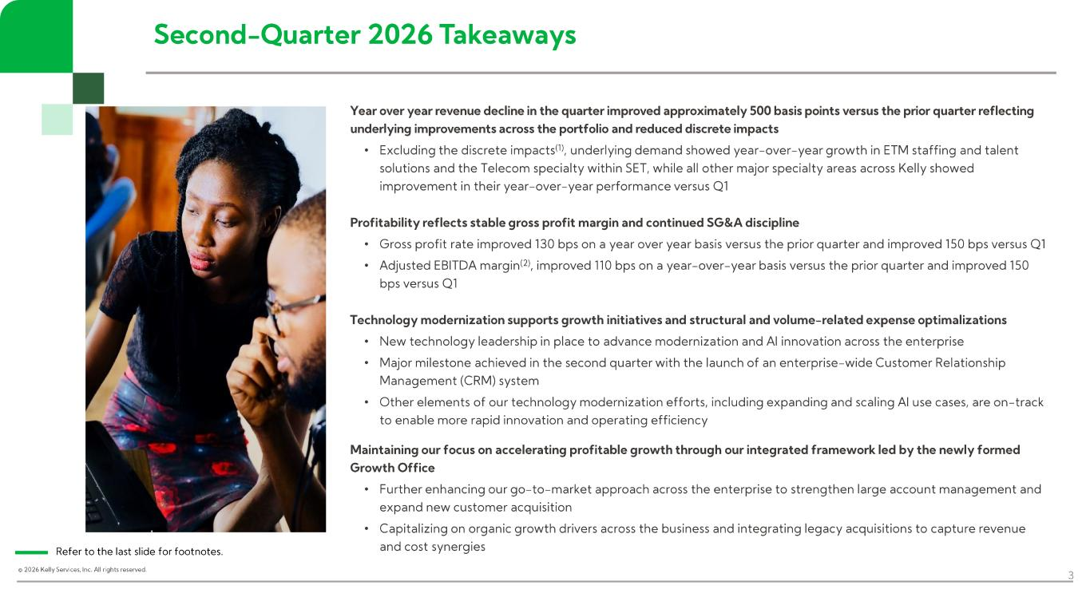
© 2026 Kelly Services, Inc. All rights reserved. Second - Quarter 2026 Takeaways 3 Year over year revenue decline in the quarter improved approximately 500 basis points versus the prior quarter reflecting underlying improvements across the portfolio and reduced discrete impacts • Excluding the discrete impacts (1), underlying demand showed year - over - year growth in ETM staffing and talent solutions and the Telecom specialty within SET, while all other major specialty areas across Kelly showed improvement in their year - over - year performance versus Q1 Profitability reflects stable gross profit margin and continued SG&A discipline • Gross profit rate improved 130 bps on a year over year basis versus the prior quarter and improved 150 bps versus Q1 • Adjusted EBITDA margin (2) , improved 110 bps on a year - over - year basis versus the prior quarter and improved 150 bps versus Q1 Technology modernization supports growth initiatives and structural and volume - related expense optimalizations • New technology leadership in place to advance modernization and AI innovation across the enterprise • Major milestone achieved in the second quarter with the launch of an enterprise - wide Customer Relationship Management (CRM) system • Other elements of our technology modernization efforts, including expanding and scaling AI use cases, are on - track to enable more rapid innovation and operating efficiency Maintaining our focus on accelerating profitable growth through our integrated framework led by the newly formed Growth Office • Further enhancing our go - to - market approach across the enterprise to strengthen large account management and expand new customer acquisition • Capitalizing on organic growth drivers across the business and integrating legacy acquisitions to capture revenue and cost synergiesRefer to the last slide for footnotes.

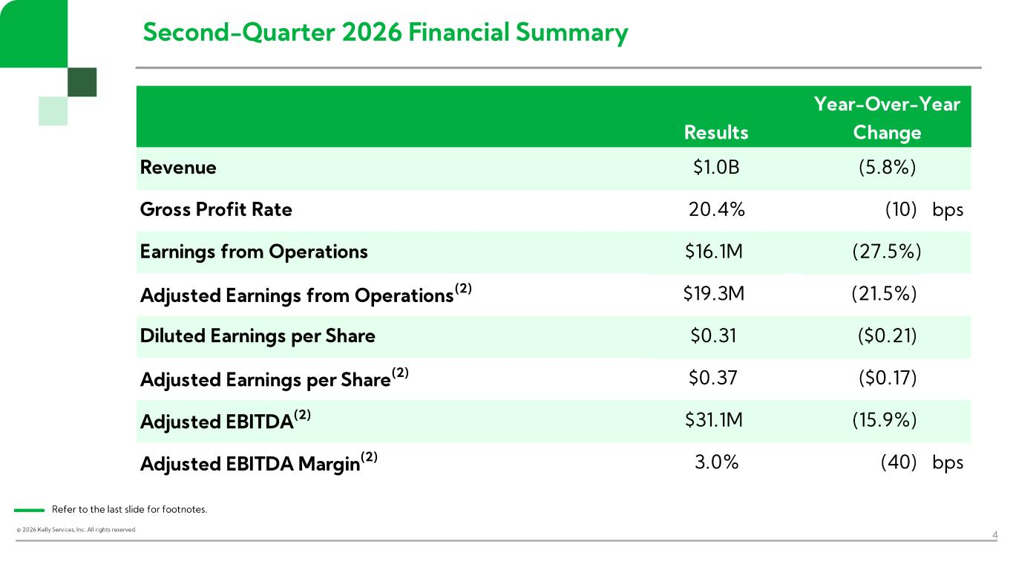
© 2026 Kelly Services, Inc. All rights reserved. Second - Quarter 2026 Financial Summary 4 Refer to the last slide for footnotes. Results Revenue $1.0B Gross Profit Rate 20.4% (10) bps Earnings from Operations $16.1M Adjusted Earnings from Operations (2) $19.3M (21.5%) Diluted Earnings per Share $0.31 ($0.21) Adjusted Earnings per Share (2) $0.37 ($0.17) Adjusted EBITDA (2) $31.1M (15.9%) Adjusted EBITDA Margin (2) 3.0% (40) bps Year-Over-Year Change (5.8%) (27.5%)

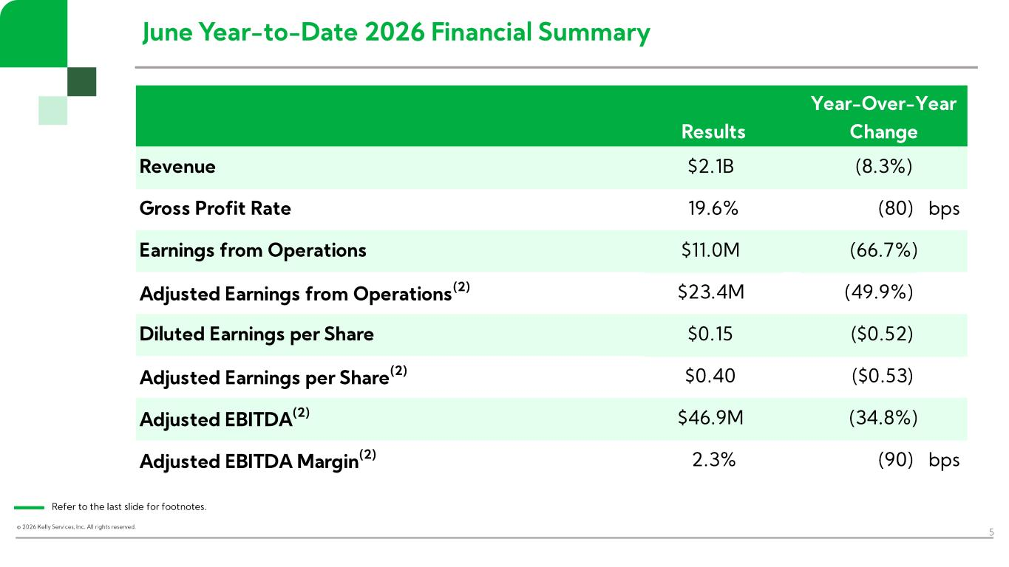
© 2026 Kelly Services, Inc. All rights reserved. June Year - to- Date 2026 Financial Summary 5 Refer to the last slide for footnotes. Results Revenue $2.1B Gross Profit Rate 19.6% (80) bps Earnings from Operations $11.0M Adjusted Earnings from Operations (2) $23.4M (49.9%) Diluted Earnings per Share $0.15 ($0.52) Adjusted Earnings per Share (2) $0.40 ($0.53) Adjusted EBITDA (2) $46.9M Adjusted EBITDA Margin (2) 2.3% (90) bps (34.8%) Year-Over-Year Change (8.3%) (66.7%)

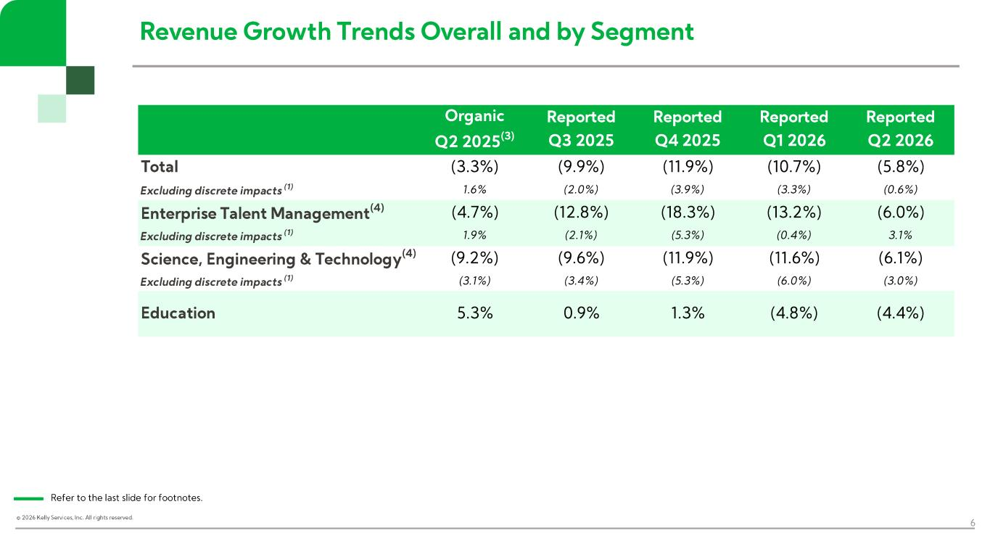
© 2026 Kelly Services, Inc. All rights reserved. Revenue Growth Trends Overall and by Segment 6 Refer to the last slide for footnotes. Organic Q2 2025 (3) Reported Q3 2025 Reported Q4 2025 Reported Q1 2026 Reported Q2 2026 Total (3.3%) (9.9%) (11.9%) (10.7%) (5.8%) Excluding discrete impacts (1) 1.6% (2.0%) (3.9%) (3.3%) (0.6%) Enterprise Talent Management (4) (4.7%) (12.8%) (18.3%) (13.2%) (6.0%) Excluding discrete impacts (1) 1.9% (2.1%) (5.3%) (0.4%) 3.1% Science, Engineering & Technology (4) (9.2%) (9.6%) (11.9%) (11.6%) (6.1%) Excluding discrete impacts (1) (3.1%) (3.4%) (5.3%) (6.0%) (3.0%) Education 5.3% 0.9% 1.3% (4.8%) (4.4%)

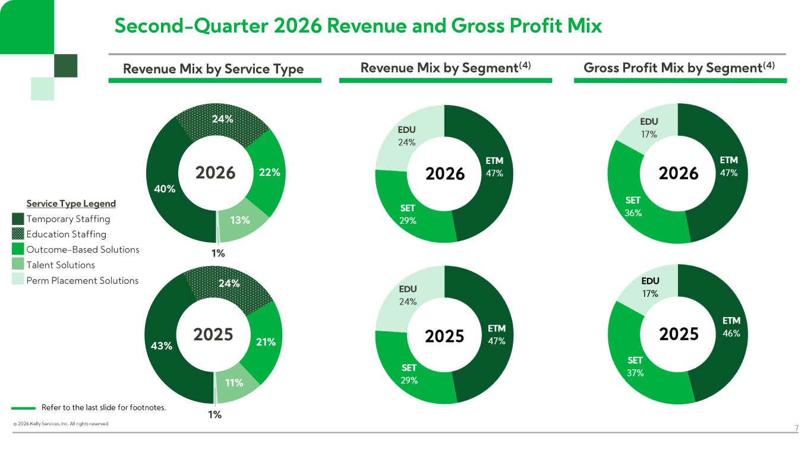
© 2026 Kelly Services, Inc. All rights reserved. 43% 24% 21% 11% 1% 2025 Second - Quarter 2026 Revenue and Gross Profit Mix 7 Revenue Mix by Service Type Gross Profit Mix by Segment (4) Refer to the last slide for footnotes. 40% 24% 22% 13% 1% 2026 Service Type Legend Temporary Staffing Education Staffing Outcome - Based Solutions Talent Solutions Perm Placement Solutions Revenue Mix by Segment (4)

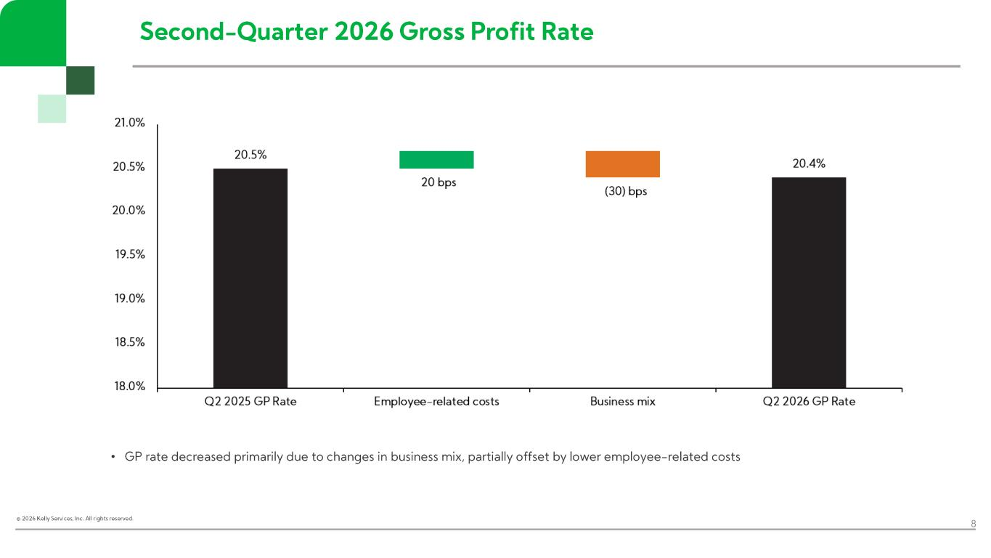
© 2026 Kelly Services, Inc. All rights reserved. Second - Quarter 2026 Gross Profit Rate 8 • GP rate decreased primarily due to changes in business mix, partially offset by lower employee - related costs

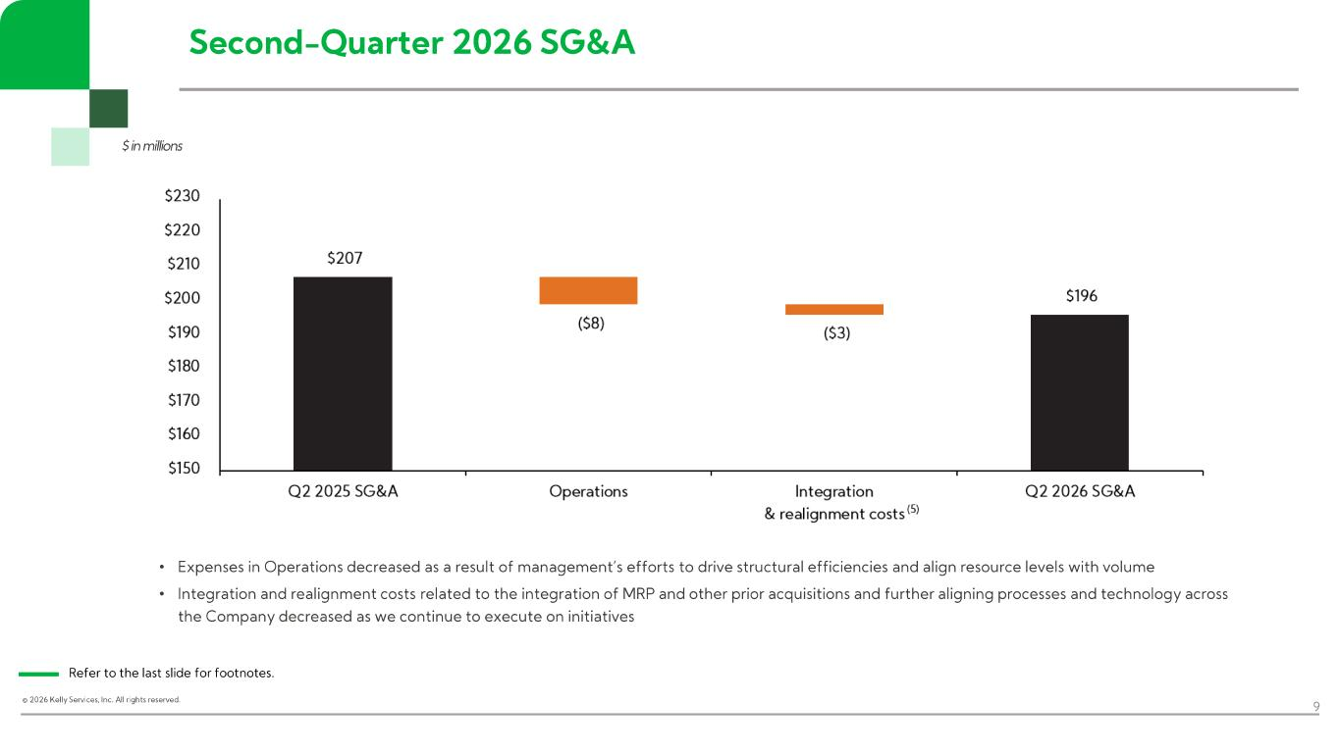
© 2026 Kelly Services, Inc. All rights reserved. 9 • Expenses in Operations decreased as a result of management’s efforts to drive structural efficiencies and align resource leve ls with volume • Integration and realignment costs related to the integration of MRP and other prior acquisitions and further aligning process es and technology across the Company decreased as we continue to execute on initiatives $ in millions Refer to the last slide for footnotes. Second - Quarter 2026 SG&A

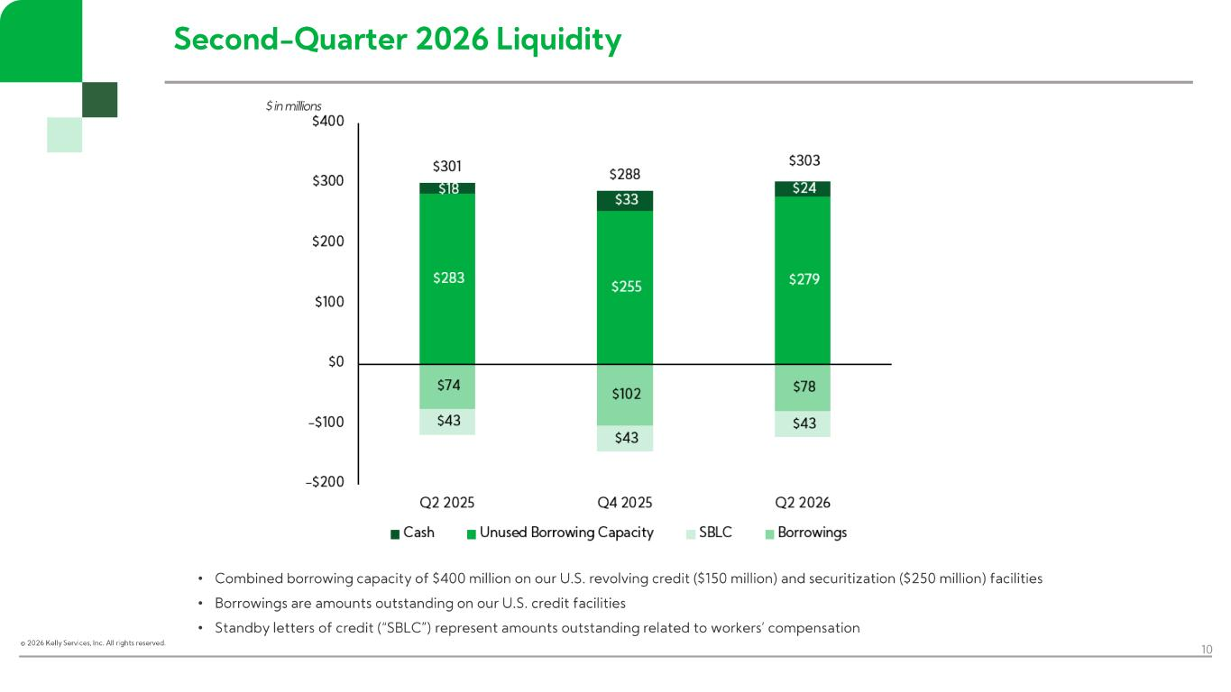
© 2026 Kelly Services, Inc. All rights reserved. Second - Quarter 2026 Liquidity 10 $ in millions • Combined borrowing capacity of $400 million on our U.S. revolving credit ($150 million) and securitization ($250 million) fac ilities • Borrowings are amounts outstanding on our U.S. credit facilities • Standby letters of credit (“SBLC”) represent amounts outstanding related to workers’ compensation

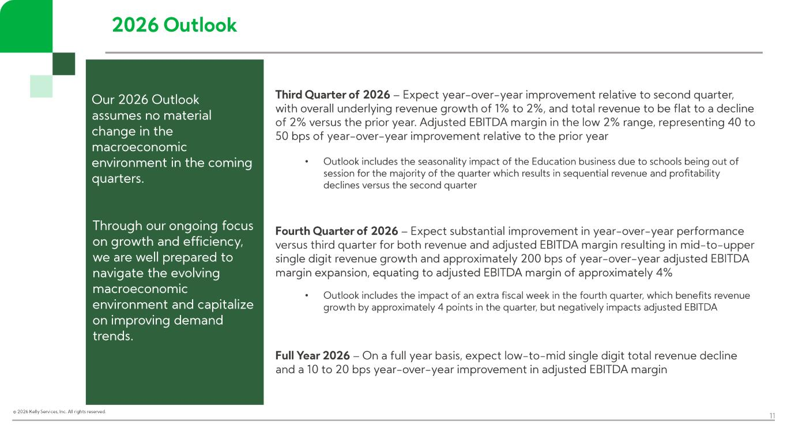
© 2026 Kelly Services, Inc. All rights reserved. 2026 Outlook 11 Our 2026 Outlook assumes no material change in the macroeconomic environment in the coming quarters. Through our ongoing focus on growth and efficiency, we are well prepared to navigate the evolving macroeconomic environment and capitalize on improving demand trends. Third Quarter of 2026 – Expect year - over - year improvement relative to second quarter, with overall underlying revenue growth of 1% to 2%, and total revenue to be flat to a decline of 2% versus the prior year. Adjusted EBITDA margin in the low 2% range, representing 40 to 50 bps of year - over - year improvement relative to the prior year • Outlook includes the seasonality impact of the Education business due to schools being out of session for the majority of the quarter which results in sequential revenue and profitability declines versus the second quarter Fourth Quarter of 2026 – Expect substantial improvement in year - over - year performance versus third quarter for both revenue and adjusted EBITDA margin resulting in mid - to- upper single digit revenue growth and approximately 200 bps of year - over - year adjusted EBITDA margin expansion, equating to adjusted EBITDA margin of approximately 4% • Outlook includes the impact of an extra fiscal week in the fourth quarter, which benefits revenue growth by approximately 4 points in the quarter, but negatively impacts adjusted EBITDA Full Year 2026 – On a full year basis, expect low - to- mid single digit total revenue decline and a 10 to 20 bps year - over - year improvement in adjusted EBITDA margin


© 2026 Kelly Services, Inc. All rights reserved. 12 Presentation Disclosures

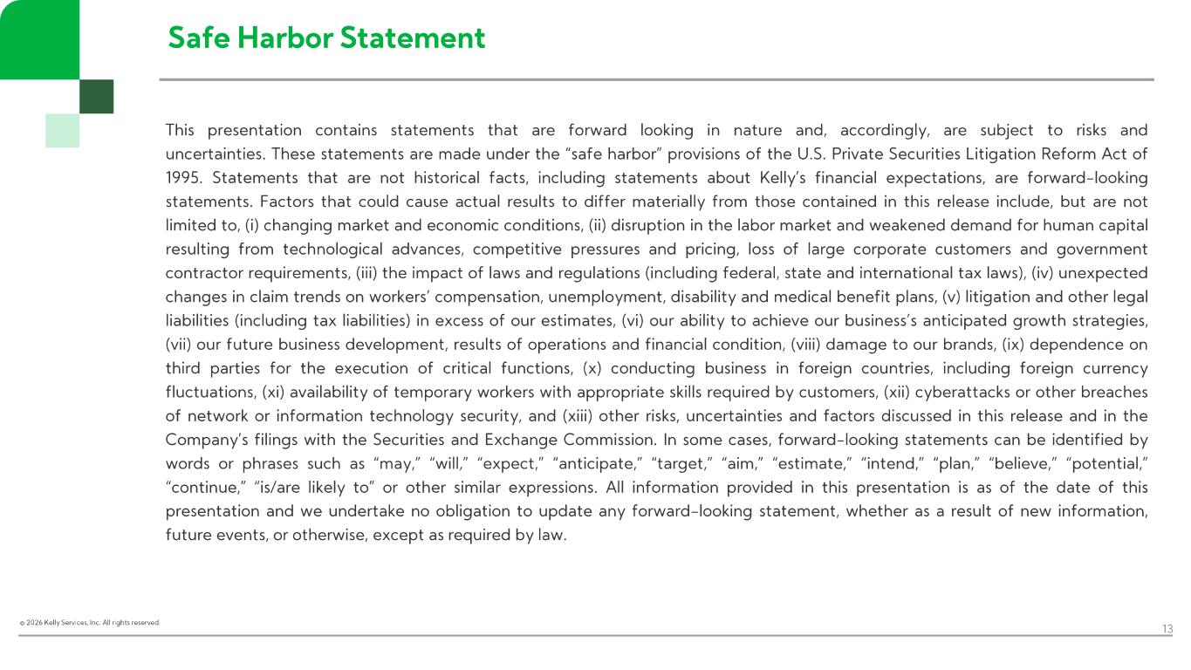
© 2026 Kelly Services, Inc. All rights reserved. 13 Safe Harbor Statement This presentation contains statements that are forward looking in nature and, accordingly, are subject to risks and uncertainties . These statements are made under the “safe harbor” provisions of the U.S . Private Securities Litigation Reform Act of 1995. Statements that are not historical facts, including statements about Kelly’s financial expectations, are forward - looking statements . Factors that could cause actual results to differ materially from those contained in this release include, but are not limited to, (i) changing market and economic conditions, (ii) disruption in the labor market and weakened demand for human capital resulting from technological advances, competitive pressures and pricing, loss of large corporate customers and government contractor requirements, (iii) the impact of laws and regulations (including federal, state and international tax laws), (iv) unexpected changes in claim trends on workers’ compensation, unemployment, disability and medical benefit plans, (v) litigation and other legal liabilities (including tax liabilities) in excess of our estimates, (vi) our ability to achieve our business’s anticipated growth strategies, (vii) our future business development, results of operations and financial condition, (viii) damage to our brands, (ix) dependence on third parties for the execution of critical functions, (x) conducting business in foreign countries, including foreign currency fluctuations, (xi) availability of temporary workers with appropriate skills required by customers, (xii) cyberattacks or other breaches of network or information technology security, and (xiii) other risks, uncertainties and factors discussed in this release and in the Company’s filings with the Securities and Exchange Commission . In some cases, forward - looking statements can be identified by words or phrases such as “may,” “will,” “expect,” “anticipate,” “target,” “aim,” “estimate,” “intend,” “plan,” “believe,” “potential,” “continue,” “is/are likely to” or other similar expressions . All information provided in this presentation is as of the date of this presentation and we undertake no obligation to update any forward - looking statement, whether as a result of new information, future events, or otherwise, except as required by law .

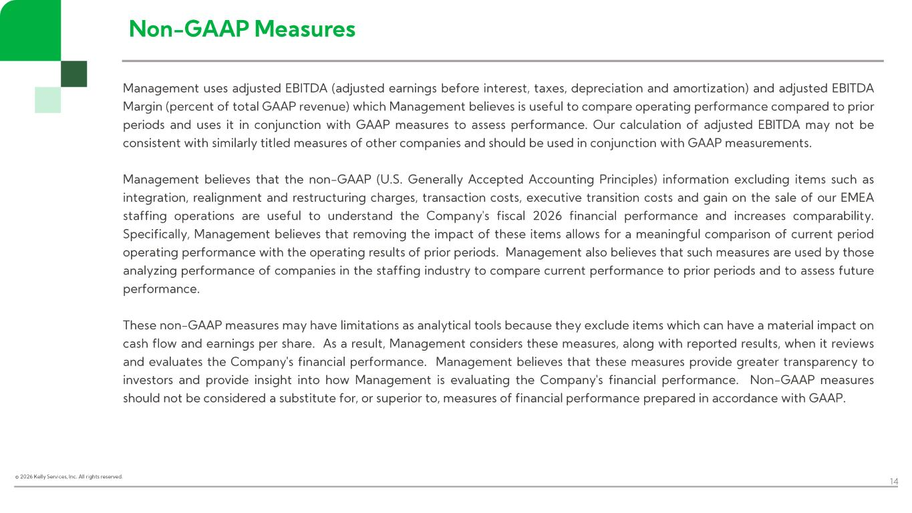
© 2026 Kelly Services, Inc. All rights reserved. 14 Non - GAAP Measures Management uses adjusted EBITDA (adjusted earnings before interest, taxes, depreciation and amortization) and adjusted EBITDA Margin (percent of total GAAP revenue) which Management believes is useful to compare operating performance compared to prior periods and uses it in conjunction with GAAP measures to assess performance . Our calculation of adjusted EBITDA may not be consistent with similarly titled measures of other companies and should be used in conjunction with GAAP measurements . Management believes that the non - GAAP (U .S . Generally Accepted Accounting Principles) information excluding items such as integration, realignment and restructuring charges, transaction costs, executive transition costs and gain on the sale of our EMEA staffing operations are useful to understand the Company's fiscal 2026 financial performance and increases comparability . Specifically, Management believes that removing the impact of these items allows for a meaningful comparison of current period operating performance with the operating results of prior periods . Management also believes that such measures are used by those analyzing performance of companies in the staffing industry to compare current performance to prior periods and to assess future performance . These non - GAAP measures may have limitations as analytical tools because they exclude items which can have a material impact on cash flow and earnings per share . As a result, Management considers these measures, along with reported results, when it reviews and evaluates the Company's financial performance . Management believes that these measures provide greater transparency to investors and provide insight into how Management is evaluating the Company's financial performance . Non - GAAP measures should not be considered a substitute for, or superior to, measures of financial performance prepared in accordance with GAAP .


© 2026 Kelly Services, Inc. All rights reserved. 15 Appendix

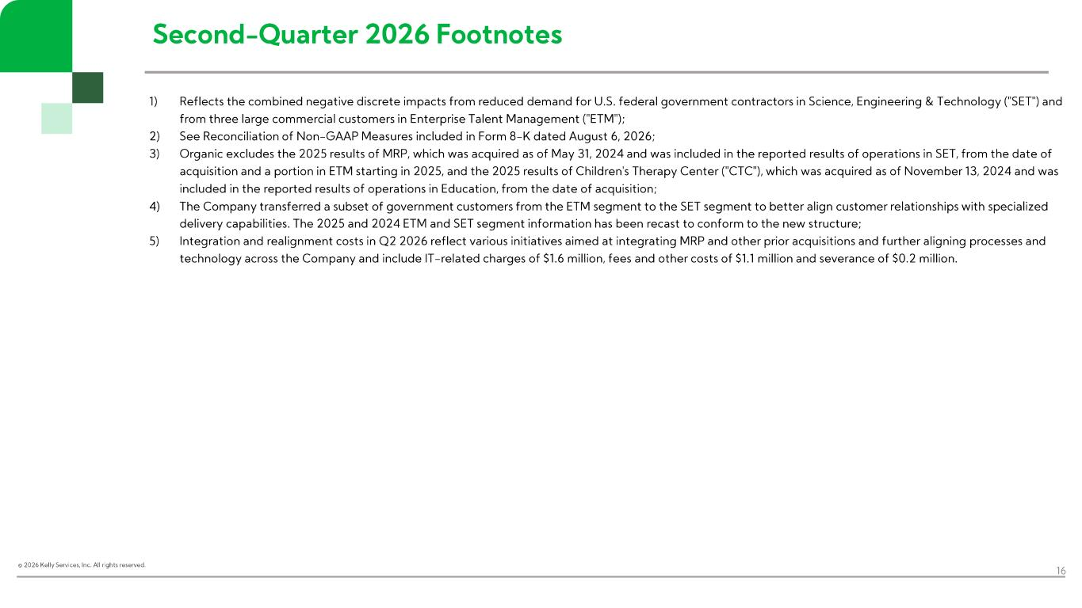
© 2026 Kelly Services, Inc. All rights reserved. Second - Quarter 2026 Footnotes 16 1) Reflects the combined negative discrete impacts from reduced demand for U.S. federal government contractors in Science, Engin eer ing & Technology ("SET") and from three large commercial customers in Enterprise Talent Management ("ETM"); 2) See Reconciliation of Non - GAAP Measures included in Form 8 - K dated August 6, 2026; 3) Organic excludes the 2025 results of MRP, which was acquired as of May 31, 2024 and was included in the reported results of o per ations in SET, from the date of acquisition and a portion in ETM starting in 2025, and the 2025 results of Children's Therapy Center ("CTC"), which was acqui red as of November 13, 2024 and was included in the reported results of operations in Education, from the date of acquisition; 4) The Company transferred a subset of government customers from the ETM segment to the SET segment to better align customer rel ati onships with specialized delivery capabilities. The 2025 and 2024 ETM and SET segment information has been recast to conform to the new structure; 5) Integration and realignment costs in Q2 2026 reflect various initiatives aimed at integrating MRP and other prior acquisition s and further aligning processes and technology across the Company and include IT - related charges of $1.6 million, fees and other costs of $1.1 million and severance of $0.2 million.

